HORMISDALLEN SCHOOL - KYEBANDO

PRE-PLE SET 7 EXAMINATIONS, 2023

PRIMARY SEVEN MATH

Duration: 2 Hours 15 Minutes

**NAME: _______________________________________ STREAM: _____________**

EMIS NO.

INDEX NO.

**SECTION A: (40MARKS)**

1. Workout: 3 × 8 using repeated addition.
2. Write the number whose standard form is 4.96 × 103
3. Given that Set P is a set of the first two prime numbers.

List all the subsets in set P.

1. Express 39 in Raman Numerals.
2. Find the range of the next two numbers in the sequence below:

18, 16, 13, 11, 8, 6, ……, ……..

1. Convert 16 40 hours into the 12 hour clock.
2. Write 24096 in words.
3. Solve form: 3m - 4 = 2m +1
4. Three pens cost shs3600. How much money can Pamela pay for seven similar pens?
5. Without the help of a protractor, construct an angle of 45o.
6. Simplify: ˉ3 - ˉ 7
7. Express 0.666………….. as a rational number in its lowest form.
8. James bought 12.5kg of meat on Christmas day. How many grams of meat did he buy on that day?
9. Study the figure below carefully to answer the question about it.

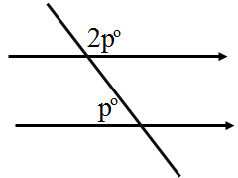

Find the value of **p**.

1. Workout the sum of the first five odd numbers.
2. **Simplify**: :
3. If P * Q = P2 – Q, evaluate 3*2
4. The area of a square flower garden is 36m2. Calculate the size of its length.
5. A workshop that lasted for 1 $\frac{1}{2}$ hours started at 11:40a.m. Calculate the ending time of the workshop in 24 hour clock system.
6. A pupil scored the following marks in a series of test 3x, 20, 30, 2x and 50. What was her average mark?

**SECTION B: (60 MARKS)**

1. a) Use digits 4, 7, 0 and 6 to form the lowest and highest four-digit numerals. (1mark @)
2. Given that 34n =19ten. Find the value of n.

(3marks)

1. 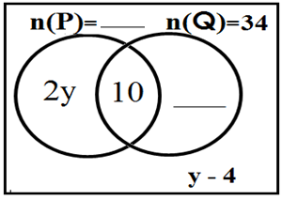Below is a Venn diagram. Study it to answer the questions.
2. Complete the Venn diagram (2marks)
3. If n(P) = 24, find the value of y. (2marks)
4. Find n($ε$) = (2marks)
5. Solve the inequality below and give the solution set:

3n - 7 ≤ 8 (3marks)

1. John is 8years old and his father is 24years old. In how many years will the father’s age be twice the son’s age? (2marks)
2. 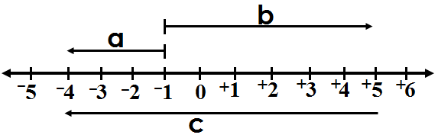Study the number line below carefully and use it to answer the questions about it**.**

1. What integers have been represented by arrows? (1mark @)

a = ___________

b = ___________

c = ___________

1. Write the Mathematical sentence for the number line above. (2marks)
2. a) Workout: $\frac{1}{2}$- $\frac{2}{3}$ + $\frac{1}{4}$ (2marks)
3. Simplify: $\frac{0.72 × 0.08}{0.12 × 0.04}$ (3marks)
4. A man had twenty thousand shillings notes numbered consecutively from AZ468600 to AZ468899.
5. How many notes did he have? (2marks)
6. How much money of twenty thousand shillings notes did he have altogether? (3marks)
7. 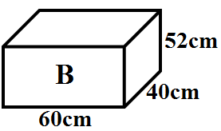In a factory, tins of A were packed in a big box B for sell.

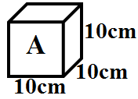

1. How many tins of **A** can be packed in box **B**?

(2marks)

1. Calculate the volume of the space left unoccupied. (3marks)
2. A father gave out land to his three children Shalom, Destiny and Godwin in the ratio of 4:5:7 respectively.
3. If Godwin got 36 more acres of land than Shalom, how many acres of land did the father give to the children?

(2marks)

1. How many acres of land did each child get?

(3marks)

1. a) What angle is a third of the complement of 21o? (2marks)
2. Find the value of **n** in the figure below:

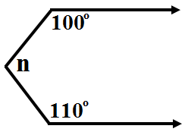(3marks)

1. Using a ruler, a pencil, and a pair of compasses only, construct a triangle **MPS** where line **MP** = 8cm, angle **MPS** = 30o and angle **PMS** = 60o. Drop a perpendicular from **S** to meet **MP** at **K**.

(4marks)

1. Measure line **SK** =………………….cm (1mark)
2. a) Workout: Hrs Min.

4 20

- 1 50

___________

(1mark)

1. A cyclist left Kampala City for Mukono a distance of 240km at a speed of 80km/hr. How many minutes did the cyclist take riding? (2marks)
2. Plot the points of the following co-ordinates: A(ˉ4,ˉ2), B(ˉ2,+2), C(+2,+2), D(+4,ˉ2).

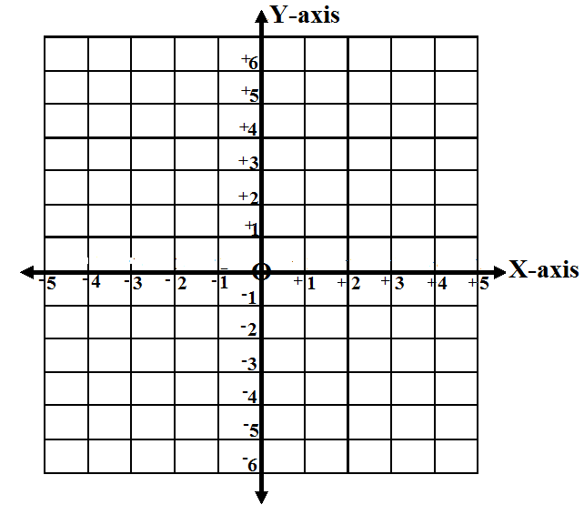 (4marks)

1. Join points A to B, B to C, C to D, D to A.

(1mark)

1. Calculate the area of the figure formed.

(1mark)

**\*\*\* Good Luck!\*\*\***